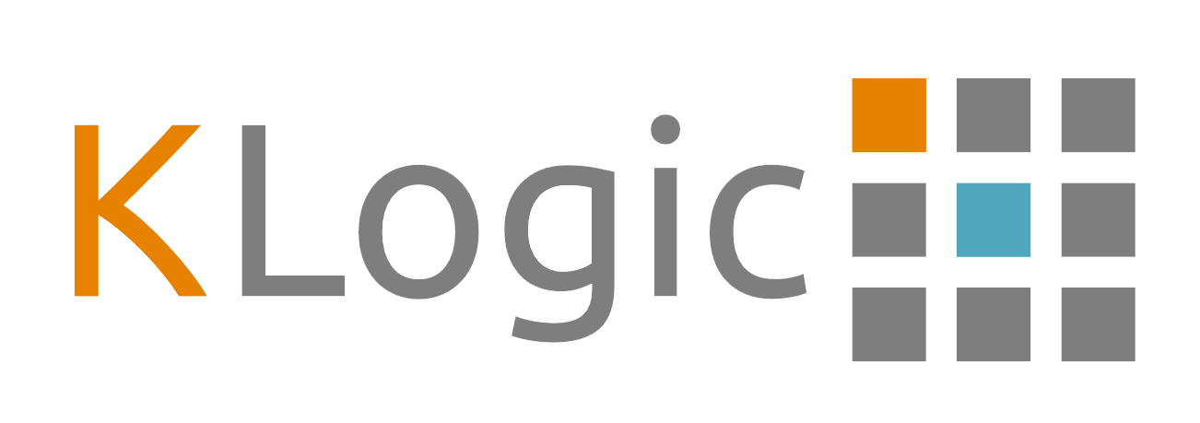

Business and Marketing Plan

Table of Contents

Executive summary 3

Business of the company 3

Goals and Objectives 4

Short term objectives: 4

Long term objectives: 4

KDebug Package for Unity 4

On Screen Developer Console 4

Debug Displays 4

Extended Unity Debug Interface 5

Market 5

Competition 6

Direct Competitors 6

Indirect Competitors 6

Pricing 7

Marketing strategy brief 7

Sales Strategy and Tactics 7

Web Presence 7

Social Media 8

PR / Media 9

References 9

Appendix 10

# Executive summary

KLogic is a game tool development company, specialising in the creation of Unity Engine systems and tools assets with the intent to help game developers fast track the development of their project. KLogic aims to develop valuable, high quality products for game developers, so they themselves don’t have to waste precious development time on creating core reusable tools and systems before even beginning their game.

KLogic is currently registered as a sole trader, run only by a single person whom also makes up the development team but plans to grow, provided the success of future and current products. KLogic hopes to one day hire additional developers as part of the team however only on a small scale in the form of a partnership. Additional developers will be required in order to expand the range and quality of products since some may require skills and toolsets not available to the sole proprietor. (Economics Online, 2019)

# Business of the company

KLogic was formed in September 2019 and began development of their first product soon after. Investments in required software licenses e.g. Unity Engine, and hardware were obtained to support the requirements of present and future projects. KLogic currently has its debut product under its portfolio; KDebug Package for Unity, with future feature updates.

KDebug Package for Unity, is a tool for developers seeking to kick start their game development process by providing valuable debug utility services. The package contains a namespace mimicking that of Unity’s Debug with some additions alongside a developer console and debug display system. Updates will follow release containing improvements to the existing utilities as well as new ones.

KLogics current business model is to release core featured assets at a low price and over time, with subsequent updates, regularly revaluate the price point for future purchases.

## Goals and Objectives

KLogic’s goal is to release a high-quality debut product and maintain it via planned, regular updates with the aim of building a known trusted reputation within the Unity developer community. In doing so, KLogic hopes to expand its developments in the future with new, sought after profitable projects.

### Short term objectives:

* Developing and releasing a high-quality debut product on the Unity Asset Store.
* To provide regular updates and maintenance to the product based on internal plans alongside monitoring feedback.
* Perform a product analysis on competitor’s products to identify key areas KLogic can improve their current products.

### Long term objectives:

* Build a strong portfolio of products known for their high quality and frequent updates.
* Expand the business to a partnership, bringing in new talent needed in key areas such as programming and art within the development team.

# KDebug Package for Unity

The KDebug Package is KLogics debut asset store product and contains a variety of features:

## On Screen Developer Console

The console can display logs output through the new KDebug interface. The console can also be used to execute debug commands entered the input field with command prediction. An interface to easily create commands is available to programmers using the package and can be registered using a single line of code. The console also features a “GameObject Context” selector, allowing the user to select objects in the scene with the console up via input, and allowing for console commands to interact with the current gameobject context giving more control to the user when debugging built version of the game.

## Debug Displays

This feature allows the programmer to easily, create and register a debug display on screen supporting the drawing of text and more. The goal of this was to bypass the setting up of references with UI objects and having programmers to spend time setting up UI just to see some on screen debug details. Programmers can instead create a debug display through overriding the base class and use the DrawText function to easily draw text line by line within the display. Debug displays can be easily registered using the static Display Manager class.

## Extended Unity Debug Interface

The KDebug package introduces a new interface for programmers to use over Unity’s default one containing the existing features of Unity’s default as well as a couple more. KLogic believes a centralised expandable Debug interface is key to avoiding clutter as well as ensuring a consistent standard is maintained within a project.

# Market

KLogic produces tools for Unity developers, specifically ones who are seeking to minimize tool development time and focus solely on game development. KLogic’s first product hits the debug tool market, widening the target audience, given any developer working on any genre of game would find utility in it.

Below is a chart from the Unity Game Studio Report 2018 illustrating the budget a typical Unity Developers studio spends on their primary project. (Unity Technologies, 2018) It shows studios spend approximately 19% of their budget on average on software/tools. KLogic is targeting this market, hoping to develop quality high demand tools at an affordable price point hoping to appeal to developers who are seeking to reduce their own spending in this area.

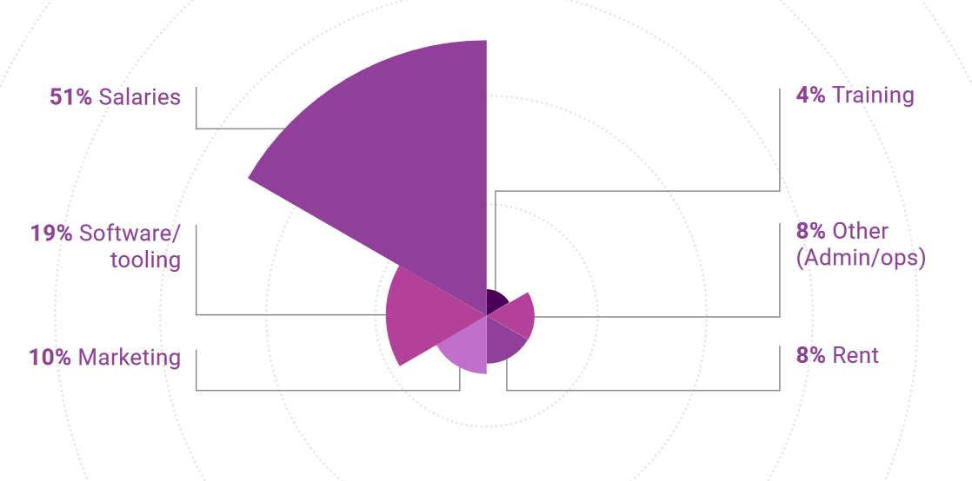

Average Studio Approximate Project Budget, Unity Technologies, 2018

Developers who purchase KLogics products will receive post purchase technical support with regards to issues or queries regarding their products. KLogic will provide free improvements to their products over time through a user feedback process. KLogic understands the necessity to perform quality assurance on their released products after each new Unity Engine update to ensure the product still works correctly. As Mallet explains, failing to do so will result in negative reviews and customers unsatisfied with their purchase. (Mallet E, 2014) KLogics chosen distribution platform is the Unity Asset Store due to it being the primary asset and tools distribution service allowing for easy targeting and distribution specifically to Unity Developers.

# Competition

KLogic has direct competitors within the Asset Store whose products will naturally compete given their similarities with regards to target market and product features. Direct competitors are publishers that produce the same type of products as KLogic on the Asset Store whereas indirect competitors are those producing products which fall into a different category or target audience. (Mirman E, 2019) Both types of competitor help make up the micro environment of the business, having an external impact on the performance of KLogic. When the competitions products sales performance is superior, it is in the interest of the company to analyse the competing products pricing and features in order to improve KLogics and compete effectively. (Oxford College of Marketing, 2014)

## Direct Competitors

Some examples of KLogic’s primary direct competitors and their products right now are:

- Stompy Robot Ltd, producers of SRDebugger. (Stompy Robot Ltd, 2019)

- QFSW, developers of Quantum Console. (QFSW, 2019)

- Miro Emanuel, creator of Runtime Console. (Miroui Emanuel, 2019)

Direct Competitors can be broken down further by categorising them into relative competition through comparing the number of features/quality of products and price to KLogics product.

Stompy Robot Ltd and QFSW’s assets can be viewed as higher tier products in comparison to KLogics Debug Package, with Miro Emanuel’s runtime console being closest feature wise. The SRDebugger and Quantum Console are higher tier due to their larger breadth of features with examples being, a built-in profiler, window docking and a console command whitelist system. Through release of future updates KLogic aims to improve and add additional features to the KDebug Package in order to eventually have a product which can compete with the higher competition.

## Indirect Competitors

With direct competitor’s products being very similar, indirect competitors are businesses which produce products within the same market place but which fall under a different category to that of KLogics. Therefore, any asset store publisher whose products are not in direct competition to KLogics will fall under this classification. The business needs to be aware of the indirect competition’s products, since emerging submarkets within the asset store can sometimes leave some products and tools redundant which would indirectly negatively affect the sales of KLogics products.

## Pricing

KLogic understands it is a new publisher within the asset store market place therefore before being able to take on higher tier competing products in both price and features it needs to establish a reputation first. The KDebug Package will be sold on the asset store initially for 6$, undercutting each direct competitor mentioned earlier, returning a sum of £3.2 per sale with the 70/30 revenue split. (Unity Technologies, 2019) The aim of this is to appeal to customers with a cheaper product with a good size of core features. With this strategy, the business aims to generate initial sales and receive constructive feedback in order to further update the product post initial release. As mentioned within the business strategy, upon release of subsequent updates and features, the company will revaluate the price of its products in relation to the competition to maximise potential revenue with hopes of eventually standing a product against the higher tier direct competitors regarding pricing.

# Marketing strategy brief

## Sales Strategy and Tactics

KLogics is hoping to position itself as a highly reputable tools developer for a wide arrange of Unity developers from sole developers to small and medium indie studios. Through releasing several sought-after products, the company aims to secure its reputation via thorough product documentation, post release updates and support to its customers. As such the company adopts a differentiation business strategy, aiming to produce products which stand out in the above areas when compared to similar competitors. (Wilkinson J, 2013) This type of strategy aims to increase the customer spending on KLogic products when customers learn to know what to expect from them. KLogic aims to do this through its core company values as well as careful market analysis not only on competitors but emerging markets within Unity Tool Assets.

## Web Presence

With KLogics products being entirely digital, it makes sense for the company to have a web presence, with the asset store encouraging publishers to have their own website before beginning to sell assets. Below is an image of KLogics website.

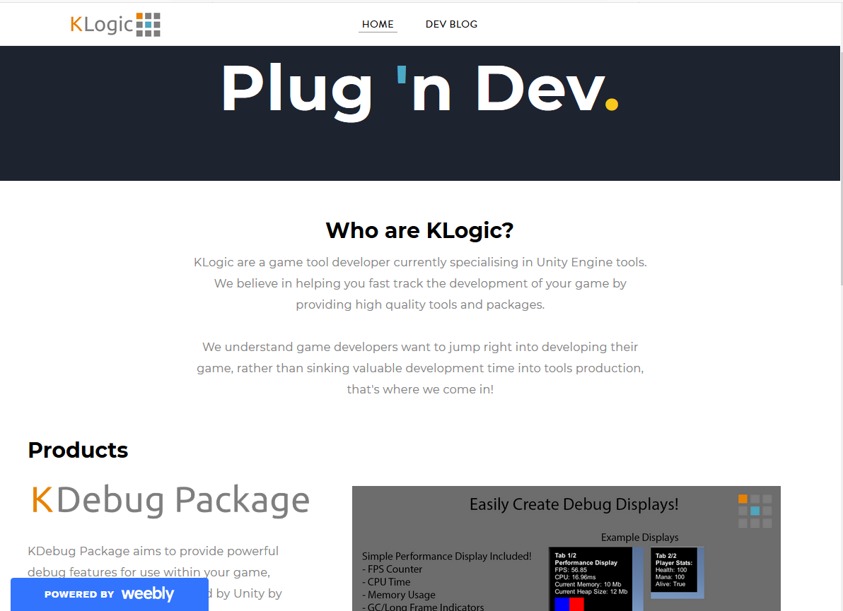

KLogics Website (https://klogicuk.weebly.com/) (Kitching A, 2019)

KLogic’s website provides potential customers with information about current and future products, detailing their primary features alongside marketing images to appeal to potential customers. The website also contains a dev blog section in which the developers periodically share work in progress updates on future products alongside other posts. KLogic understands the appeal of giving customers and insight into the development process of the company as it not only shows the progress of projects, but it also helps assist in building trust between the business and customer. Contact details for KLogic are also found on the website for any customers with queries or suggestions regarding KLogic products.

## Social Media

With the widespread use of social media in todays society, KLogic aims to establish itself within primary social media platforms in order to maximize potential reach as well as being an effective way to communicate with the community. As Zarella writes, many small businesses can and have previously, vastly increased their products reach through effective use of social media with use of both promotional images and videos. (Zarella D, 2009) With millions of users every day KLogic has chosen to setup both a Twitter and Facebook account for the business allowing it to freely post marketing material and updates to followers on a regular basis. With a platform to increase product visibility and reach the business is hoping social media will play a positive role in increasing product sales and establishing a reputable name for the business.

## PR / Media

Not only is KLogic taking advantage of social media, it is also aware of other forms of online media and how they can be used such as YouTube for example. YouTube is home to many content creators, some of which whom test and review game assets on their channel, not only providing feedback to the developers but also serving as way for potential customers to gain an insight and second opinion on products before they purchase. One example of a popular content creator of this type on YouTube is Sykoo, who produces content like this for his 171k subscribers to view with many videos of this type returning thousands of hits. (Sykoo, 2019) As a business, KLogic sees the potential and positive impact this type of media can have on its product’s sales performance and therefore plans to reach out to many of these types of ‘influencers’. KLogic would request they review their product by providing them with a free copy in order to do so. This form of media is a cheap effective way of increasing reach through another follower base, providing the reviews and feedback are positive. However, it can backfire, with negative reviews or feedback resulting in an adverse effect, spreading a negative opinion to potential customers.

# References

1. Economics Online. (2019) What is enterprise. Available from: <https://www.economicsonline.co.uk/Business_economics/What_is_enterprise.html> [Accessed: 19 November 2019]
2. Kitching, A. (2019) KLogic Website. Available from: <https://klogicuk.weebly.com/> [Accessed: 10 December 2019]
3. Mallet, E. (2014) Selling on the Unity Asset Store. Available from: <https://www.gamasutra.com/blogs/ErnestMallett/20140326/214014/Selling_on_the_Unity_Asset_Store.php> [Accessed: 8 December 2019]
4. Mirman, E (2019) Competitor Tiers: How to Break Down Your Competitive Landscape. Available from: <https://www.crayon.co/blog/competitor-tiers-how-to-break-down-your-competitive-landscape> [Accessed: 8 December 2019]
5. Miroui E. (2019) Runtime Console. Available from: <https://assetstore.unity.com/packages/tools/gui/runtime-console-85795> [Accessed: 22 November 2019]
6. Oxford College of Marketing. (2014) The Impact of Micro and Macro Environment Factors On Marketing. Available from: <https://blog.oxfordcollegeofmarketing.com/2014/11/04/the-impact-of-micro-and-macro-environment-factors-on-marketing/> [Accessed: 10 December 2019]
7. QFSW. (2019) Quantum Console. Available from: <https://assetstore.unity.com/packages/tools/utilities/quantum-console-128881> [Accessed: 22 November 2019]
8. Stompy Robot Ltd. (2019) SRDebugger – Console & Tools On-Device. Available from: <https://assetstore.unity.com/packages/tools/gui/srdebugger-console-tools-on-device-27688> [Accessed: 22 November 2019]
9. Sykoo. (2019) Sykoo’s Youtube Channel. Available from: <https://www.youtube.com/user/SykooTV> [Accessed: 10 December 2019]
10. Unity Technologies. (2018) Game Studio Report 2018. Available from: <https://unity3d.com/game-studio-report-2018> [Accessed: 8 December 2019]
11. Unity Technologies. (2019) Asset Store Publisher Revenue Split. Available from <https://unity3d.com/asset-store/sell-assets> [Accessed: 10 December 2019]
12. Willkinson, J (2013) Market Positioning. Available from: <https://strategiccfo.com/market-positioning/> [Accessed: 8 December 2019]
13. Zarella, D (2009) *The Social Media Marketing Book,* O’Reilly Media, p.7

# Appendix

In-Progress screenshots can be found on KLogics website listed within the references, underneath the dev blog section.